**SRM INSTITUTE OF SCIENCE AND TECHNOLOGY**

**DEPARTMENT OF COMPUTER SCIENCE AND ENGINEERING**

**KATTANKULATHUR – 603 203**

**15IT304J- Web Programming Register Number: RA1711003011471**

**Name: Manvi Singh Chandel**

**Experiment No: 6**

**Date: 27/10/2020**

**Aim:**  **Design a dynamic web page with validation using JavaScript**

**Input:**

**HTML Code:-**

<!DOCTYPE html> <html lang="en"> <head> <meta charset="UTF-8"> <title>Simple HTML Form</title> <link rel="stylesheet" href="style.css"> <script src="validator.js"></script> </head> <body> <form name="contactForm" onsubmit="return validateForm()" action="confirmation.php" method="post">

<h2>Application Form</h2> <div class="row">

<label>Full Name</label> <input type="text" name="name">

<div class="error" id="nameErr"></div>

</div> <div class="row"> <label>Email Address</label>

<input type="text" name="email">

<div class="error" id="emailErr"></div>

</div> <div class="row"> <label>Mobile Number</label> <input type="text" name="mobile" maxlength="10">

<div class="error" id="mobileErr"></div> </div>

<div class="row"> <label>Country</label> <select name="country"> <option>Select</option>

<option>Australia</option> <option>India</option> <option>United States</option> <option>United Kingdom</option> </select> <div class="error" id="countryErr"></div> </div>

<div class="row"> <label>Gender</label> <div class="form-inline"> <label><input type="radio" name="gender" value="male"> Male</label> <label><input type="radio" name="gender" value="female"> Female</label> </div> <div class="error" id="genderErr"></div>

</div> <div class="row">

<label>Hobbies <i>(Optional)</i></label> <div class="form-inline"> <label><input type="checkbox" name="hobbies[]" value="sports"> Sports</label>

<label><input type="checkbox" name="hobbies[]" value="movies"> Movies</label> <label><input type="checkbox" name="hobbies[]" value="music"> Music</label> </div>

</div> <div class="row"> <input type="submit" value="Submit"> </div> </form> </body> </html>

**CSS Code:-**

body {

font-size: 16px; background: #f9f9f9; font-family: "Segoe UI", "Helvetica Neue", Arial, sans-serif; }

h2 { text-align: center; text-decoration: underline; }

form { width: 300px; background: #fff; padding: 15px 40px 40px; border: 1px solid #ccc; margin: 50px auto 0; border-radius: 5px; }

label { display: block; margin-bottom: 5px }

label i { color: #999; font-size: 80%; }

input, select { border: 1px solid #ccc; padding: 10px; display: block; width: 100%; box-sizing: border-box; border-radius: 2px; }

.row { padding-bottom: 10px; }

.form-inline { border: 1px solid #ccc; padding: 8px 10px 4px; border-radius: 2px; }

.form-inline label, .form-inline input { display: inline-block; width: auto; padding-right: 15px; }

.error { color: red; font-size: 90%; }

input[type="submit"] { font-size: 110%; font-weight: 100; background: #006dcc; border-color: #016BC1; box-shadow: 0 3px 0 #0165b6; color: #fff; margin-top: 10px; cursor: pointer; }

input[type="submit"]:hover { background: #0165b6; }

**JavaScript:-**

function printError(elemId, hintMsg) { document.getElementById(elemId).innerHTML = hintMsg; } {var name = document.contactForm.name.value; var email = document.contactForm.email.value; var mobile = document.contactForm.mobile.value; var country = document.contactForm.country.value; var gender = document.contactForm.gender.value; var hobbies = []; var checkboxes = document.getElementsByName("hobbies[]"); for(var i=0; i < checkboxes.length; i++) { if(checkboxes[i].checked) { hobbies.push(checkboxes[i].value); } } emailErr = mobileErr = countryErr = genderErr = true;

if(name == "") { printError("nameErr", "Please enter your name"); } else { var regex = /^[a-zA-Z\s]+$/; if(regex.test(name) === false) { printError("nameErr", "Please enter a valid name"); }

else { printError("nameErr", ""); nameErr = false; } } if(email == "") { printError("emailErr", "Please enter your email address"); } else { var regex = /^\S+@\S+\.\S+$/; if(regex.test(email) === false) { printError("emailErr", "Please enter a valid email address"); } else{ printError("emailErr", "");

emailErr = false; } } if(mobile == "")

{ printError("mobileErr", "Please enter your mobile number"); }

else { var regex = /^[1-9]\d{9}$/; if(regex.test(mobile) === false)

{ printError("mobileErr", "Please enter a valid 10 digit mobile number"); } else

{ printError("mobileErr", ""); mobileErr = false; } } // Validate country if(country == "Select")

{ printError("countryErr", "Please select your country"); }

else { printError("countryErr", ""); countryErr = false; } if(gender == "") { printError("genderErr", "Please select your gender"); } else { printError("genderErr", ""); genderErr = false; }

if((nameErr || emailErr || mobileErr || countryErr || genderErr) == true) { return false; } else

{ dataPreview = "You've entered the following details: \n" + "Full Name: " + name + "\n" + "Email Address: " + email + "\n" + "Mobile Number: " + mobile + "\n" + "Country: " + country + "\n" + "Gender: " + gender + "\n"; if(hobbies.length)

{ dataPreview += "Hobbies: " + hobbies.join(", "); }

alert(dataPreview); } };

**OUTPUT:-**

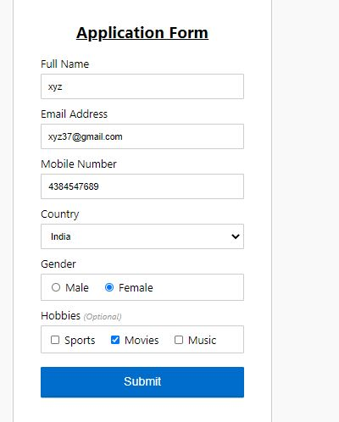

**Result: Dynamic web page with validation using JavaScript**

**designed successfully.**